Pesticides, fuels and some industrial chemicals are classified as Hazardous Chemicals in State Work Health and Safety Regulations.

The National Code of Practice for the Storage of Hazardous Chemicals has a list of Hazardous Chemical Groups that describes:
- Placard Quantities - the threshold quantities (when exceeded) where signage is required to identify products stored, and
- Manifest Quantities - threshold quantities (when exceeded) to inform emergency services of the location, category and quantities of Hazardous Chemicals stored on farm.

What does the storage of Hazardous Chemicals Regulations require?

If you store pesticides, fuel, diesel and other industrial chemicals (hazardous chemicals) on your farm, you must store them securely and keep a record (register) of all hazardous chemicals stored.

Information on how to safely store agricultural chemicals can be found in the Australian Standard AS2507:1998 - the storage and handling of agricultural and veterinary chemicals.

Who does the law apply to?

The law applies to all farm businesses.

Do I have to record my own
household chemical use?

No. You do not need to make a record when you use or store pesticides around your own home or garden.

What chemicals are included?

All pesticides (including herbicides, fungicides, insecticides, fumigants, bactericides, rodenticides, baits, lures, repellents and pesticides used on animals to control external parasites).

Petrochemicals (including fuels, industrial gasses, diesel, ULP, kerosene, avgas, avtur). Some industrial chemicals (including solvents, sanitisers and disinfectants).

How do I store agricultural chemicals, fuels and other Hazardous Chemicals securely?

For agricultural chemicals (pesticides) - store in a secure, ventilated, well lit store with an impervious floor that that is bunded to contain spills. A First Aid kit with an emergency eye wash, an Emergency Plan and directions, and a Spill Recovery Kit to clean up and dispose of any chemical spills.

You are required to separate hazardous chemical groups e.g. Poisons from Flammable products. It is also good practice to separate herbicides,
insecticides, fungicides and animal health products, including products used to control animal ectoparasites and insects (blowfly, lice and ticks) so they are not mixed up and accidentally misused.

What is a bund and how big does it have to be?

A bund is a wall surrounding a chemical store that will contain chemical spills. For farm chemical stores, build a bund that will contain 100% of the largest container or 25% of the total volume stored, whichever is the greater.

Spillage containment may be:
- a sloping floor (with or without a sump, holding pit or tank)
- a bunded area
- trenches or spoon drains, or a combination of the above

What is an Emergency Spill Kit?

An emergency spill kit contains:
- a recovery drum large enough to contain the largest container (to put leaking drums in)
- funnel and decanting tap or siphon pump
- hydrated lime or soda ash (to decontaminate spills)
- sand, soil or other chemical absorbent (to help cleanup spills)
- a shovel and broom, and
- PPE e.g. gloves, apron, eye protection to use when cleaning up spills

First Aid Kit, Fire Extinguisher and Emergency
Eye Wash

There should be a suitable Fire Extinguisher, a First Aid Kit (with a Portable Eye Wash Kit, (at least 250 mL Eye Wash bottle) and an Emergency Shower freely accessible in or adjacent the store.

Safety information, emergency plans and directions

There should be Safety Information / Safety Data Sheets (SDS), an Emergency Plan with Directions and First Aid Procedures describing what to do and who to contact in the event of a spill or emergency.

What records do I keep?

You are asked to keep a record of all quantities of Hazardous Chemicals stored and Pesticides used on the farm. These are your Chemical Register and Pesticide Application Records.

A Chemical Register records the:
- Name and quantity of the products stored, and
- The Hazardous Category of each product.

The Chemical Label and Safety Data Sheet have information about the hazards associated with each pesticide and chemical.

Examples of registers you can use are the Chemical Inventory from
Livestock Producer Assurance or the version in this document.

Fuel Tanks

All fuel tanks (regardless of quantity stored) should be placarded with their Contents and the Safe Fill Limit (SFL) on each tank; minimum 100mm black letters on a white or silver background. The Safe Fill Limit is usually 95% of the total volume of the tank.

Product Signage
Petrol Tanks Unleaded Petrol or ULP
e.g. 2,000 L = SFL 1,900 litres
Diesel Tanks Diesel
e.g. 5,000 L = SFL 4,750 litres

When placard quantities are exceeded, what signs do I need on my Fuel Store?

When the Placard Quantities of petrochemicals (fuels) are exceeded, the following signage is placed on the outside of the tank or store.
Product | GHS  Hazard Class | GHS  Hazard Category | Placard Quantity | Manifest Quantity
Petrol | Flammable Liquids | Category 2 | 250 L | 2,500 L
Diesel Combustible Liquid | Flammable Liquids | Category 4 | 10,000 L | 100,000 L

Diesel Stores / Tanks

An example when the Placard Quantity (10,000 L of Diesel Flammable Liquid, Category 4) or more of diesel is stored in one store or tank.

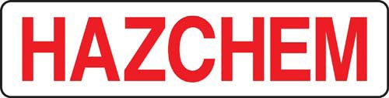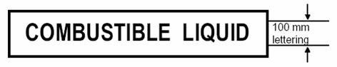

Petrol Stores / Tanks

An example when the Placarded Quantity (2,500 L of petrol; Flammable Liquid, Category 2) is exceeded.
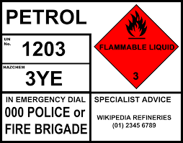

Pesticide Stores

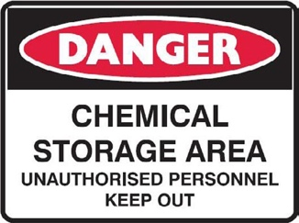
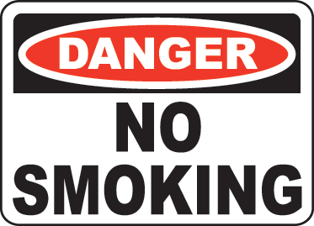
All pesticide and chemical stores should be placarded with Danger Signs and where required No Smoking signs e.g.

When placard quantities are exceeded, what signs do I need on my Pesticide Store?

When Placard Quantities are exceeded (in the table below), the following HAZCHEM and existing Dangerous Goods Diamonds are used and placed on the outside of the pesticide / chemical store.

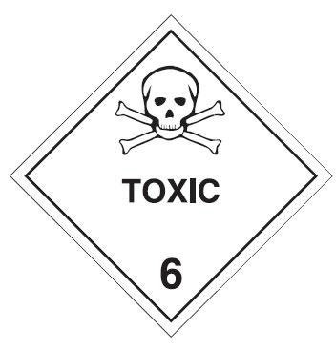
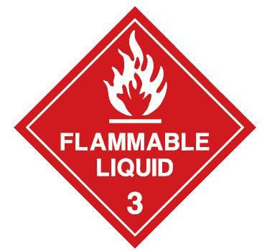
The HAZCHEM sign is a minimum 100 mm high red lettering on a silver or white background. Examples are:

This Table is a summary of the Placard and Manifest Quantities for the storage of Hazardous Chemicals with Acute Toxicity or those that are Flammable Liquids.
DG Products | GHS Hazard Class | GHS Hazard Category | Placard Quantity (L or kg) | Manifest Quantity (L or kg)
Poisons  6.1 (PG II)  Flammables 3 (PG II) | Acute Toxicity or  Flammable Liquids | Category 1 | 50 | 500
 |  | Category 2 | 250 | 2,500
 |  | Category 3 | 1,000 | 10,000

When Manifest Quantities are exceeded,
how do I develop a Manifest and Site Plan?

You then develop a Hazardous Chemical Manifest and Site Plan.

This Chemical Manifest is registered with your State Work Health and Safety Authority and is available to Emergency Services to provide advice on what quantities and types of Hazardous Chemicals are involved in an emergency.

The site plan is a map of the farm (it can be hand drawn) showing where Hazardous Chemicals are stored.

The labelling of Hazardous Chemicals is being replaced by the Globally Harmonized System of Classification and Labeling of Chemicals (GHS).

GHS is an internationally agreed-upon system for the labelling of Hazardous Chemicals with further references to providing safety information (including hazard based statements) on the label and in Safety Data Sheets.

This information can be found in the Safe Work Australia website in the model Codes of Practice; Managing Risks of Hazardous Chemicals in the Workplace

http://www.safeworkaustralia.gov.au/sites/swa/about/publications/ pages/managing-risks-of-hazardous-chemicals-in-the-workplace

Product Name | Company | Active | Pack / Tank Size | Quantity (L or kg)
eg Roundup CT | eg Roundup CT | glyphosate | 20 L | 48
eg Spray Seed | Syngenta | paraquat and diquat | 20 L | 60
ULP | Caltex | unleaded petrol | 200 L | 400
Diesel | Caltex | diesel | 2,500 L | 2,500

Product Name | Active | Pack Size | Quantity (L or kg) | Item | Hazard Class | PG | Sub Class | Poison Schedule | UN  Number | Where Stored | Current SDS Date
eg Roundup CT | glyphosate | 20 L | 48 | N/A |  |  |  | S5 | 3082 | Chemical Shed | 20/12/2010
Spray Seed | paraquat and diquat | 20 L | 60 | 35 | 6.1 | III |  | S7 | 3016 | Chemical Shed | 10/08/2008
Rogor | dimethoate | 20 L | 15 |  | 6.1 | III | 3 | S6 | 3017 | Chemical Shed | 01/05/2009
ULP | unleaded petrol | 200 L Drums | 400 L | 8 | 3 | II |  | N/A | 1203 | Bowser | 01/05/2010
Diesel | diesel | 2,500 L Tank | 2,500 L | 10 | CI |  |  | S5 | 1298 | Shed Tank | 01/02/2007

RIRDC Project No PRJ-010097/010099

